MCNA00862_0000[1]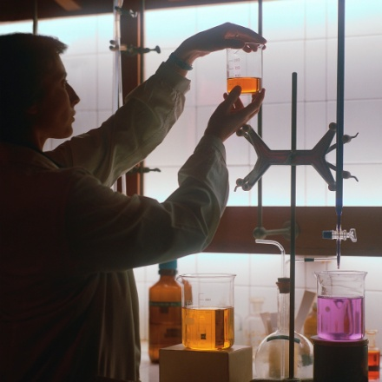C:\Documents and Settings\savagedan\Local Settings\Temporary Internet Files\Content.IE5\X7V77W46\MCj04398510000[1].wmf

3089 Manchester Road

Akron, OH 44319

Phone: 330.644.3004 x 625087

<http://www.coventryschools.org/DannySavage.aspx>

E-mail address: dsavage@coventryschools.org

# Coventry High School

1st Period

7:42 am – 8:32 am

Lab Fee - $7

**High School:** Hoover High School

**College:** Baldwin-Wallace College

**Interests:** Running, basketball, skiing, volleyball, tennis, reading, crosswords, puzzles, outdoors

**Favorite Sports Teams:** Cleveland Browns, Cleveland Indians, Cleveland Cavs, The Ohio State University

**Favorite TV Shows:** The Office, It’s Always Sunny in Philadelphia, Sons of Anarchy, The Following

**Favorite Movie:** X-Men or Batman

**Favorite Book:** The Elements

**Favorite Quote:** “To give less than your best is to sacrifice the gift” - Steve Prefontaine

**My Pet Peeves**

1. Leaving garbage in the sinks or troughs

2. Not putting stuff back where it belongs

3. Writing on the chalkboard

Two sodium atoms were walking

along the street when one stops and says, "Oh my goodness, I think I've lost an electron!" "Are you sure?" asks his companion. "Yes," replies the first sodium atom. "I'm positive."

### About Me

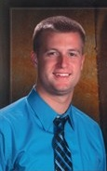

# Welcome to

**CHEMISTRY**

## Adv Chem

## Mr. Savage

## Room 104

Homework

Homework will be given frequently, with many opportunities to finish it in class. Should you not finish it, it is expected to be completed at the ***beginning of class*** on the due date in order to receive full credit. Homework can be turned in a day late for half credit.

Homework is to be put in the correct file tray correlating to your class. It is your responsibility to make sure you put it in the correct tray. I will not accept the excuse of “I put it in the wrong tray.”

I will *try* not to assign homework on Fridays that will be due on Mondays.

Grading

I will follow the Coventry Local School District’s policy for grading…

A = 90-100

B = 80-89

C = 70-79

D = 60-69

F = 59 and below

All courses are graded on a 4.0 scale. Passing mark is a “D.” College recommending mark is a “C.”

Cheating will result in an automatic 0.

Extra credit opportunities will be few and far between.

Top 10 Lab Rules

(in no particular order)

1. ABSOLUTELY NO HORSEPLAY
2. No eating, drinking, or chewing gum
3. Goggles and aprons must be worn at all times during specified labs
4. Shoes must be worn during specified labs. I suggest you keep an old pair of shoes in your locker so you don’t have to sit out
5. Only mix chemicals when you are told to do so
6. Long hair must be tied back and loose sleeves must be rolled up
7. Know the location of ALL safety equipment in the classroom
8. Alert teacher when an accident has occurred. I will not be mad as long as you let me know right away
9. Do not eat, drink, or smell any chemicals unless given permission
10. When in doubt, ASK! I am here to help you succeed

Classroom Rules and Procedures

The following are a suggested list of classroom rules and procedures. If you follow these, your time in this class will be well spent.

1. Respect me and I will respect you.
2. Treat others the way you like to be treated.
3. Raise your hand to speak and speak only when you are called upon, unless otherwise given permission.
4. Be in your seats and ready to learn when the bell rings.
5. Only use lab equipment when doing a lab.
6. When borrowing supplies, please put them back where they belong.
7. No horseplay. Since we are in a lab classroom, any sign of horseplay will not be tolerated and the consequences will be assigned appropriately.
8. Have fun!

Classroom Consequences

If you choose to not follow the rules and procedures, consequences will be assigned as follows…

1. Troughs!
2. Cleaning detention – cleaning the hairy drains, crusty sinks, etc. during your study hall
3. After school detention
4. Call home to parents
5. Office referral

### Homework and Grading Policy